**1.Create an Increment button using useState hook.**

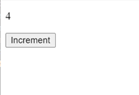

**2.Create a clock using useState hook.**

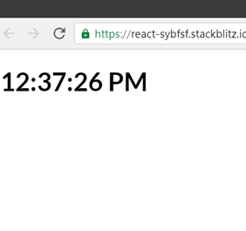

**3.Creating an Increment button using useState and useEffect to show alert after button click.**

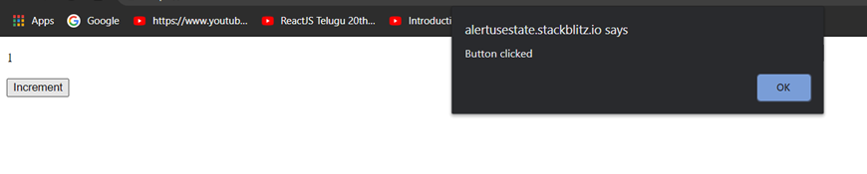

**4.Using useContext Hook create 3 Components A,B and C respectively. use C component in B,B Component in A, and A Component in App.js.Now use createContext, Provider and pass the value to C Component.**



**5.Using useContext Hook, change the color of the background.**

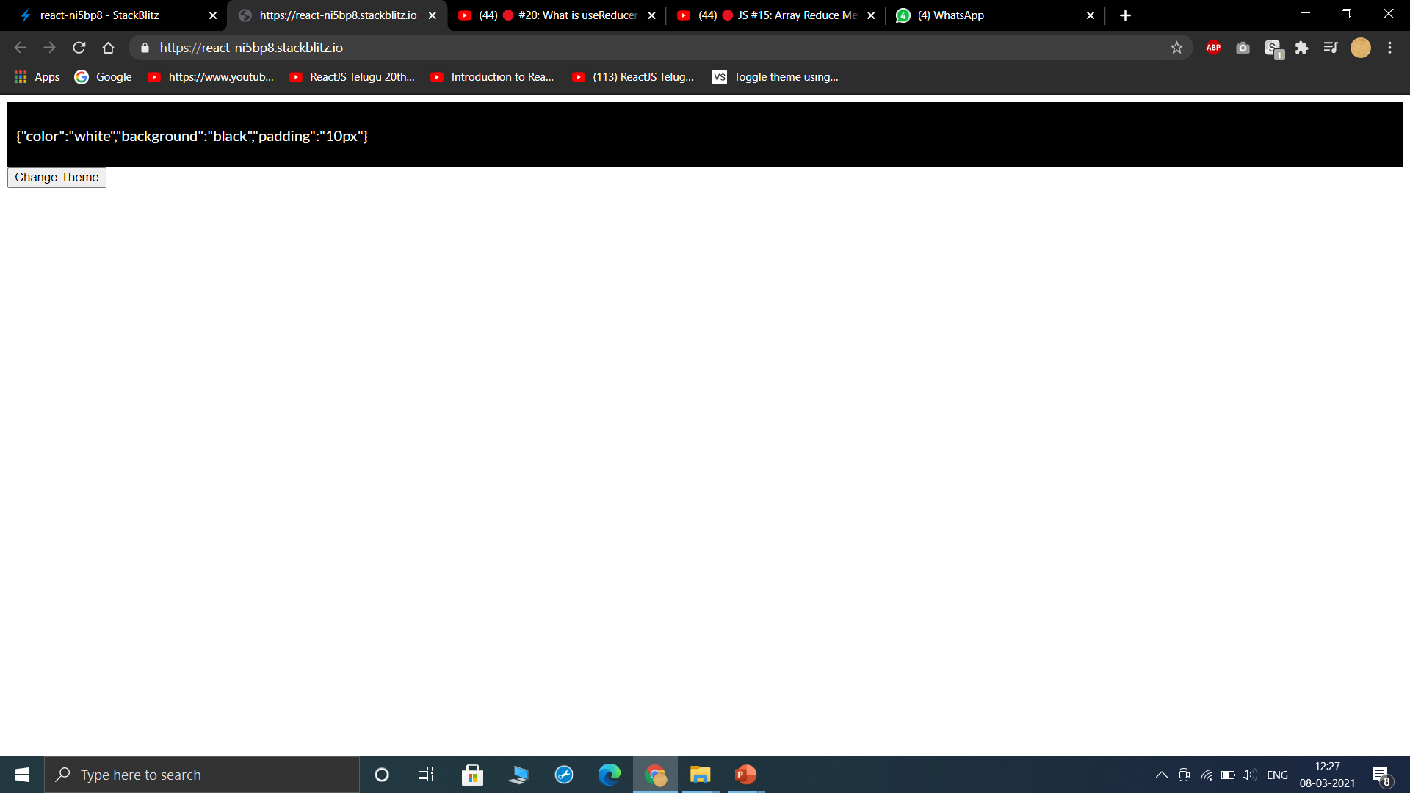

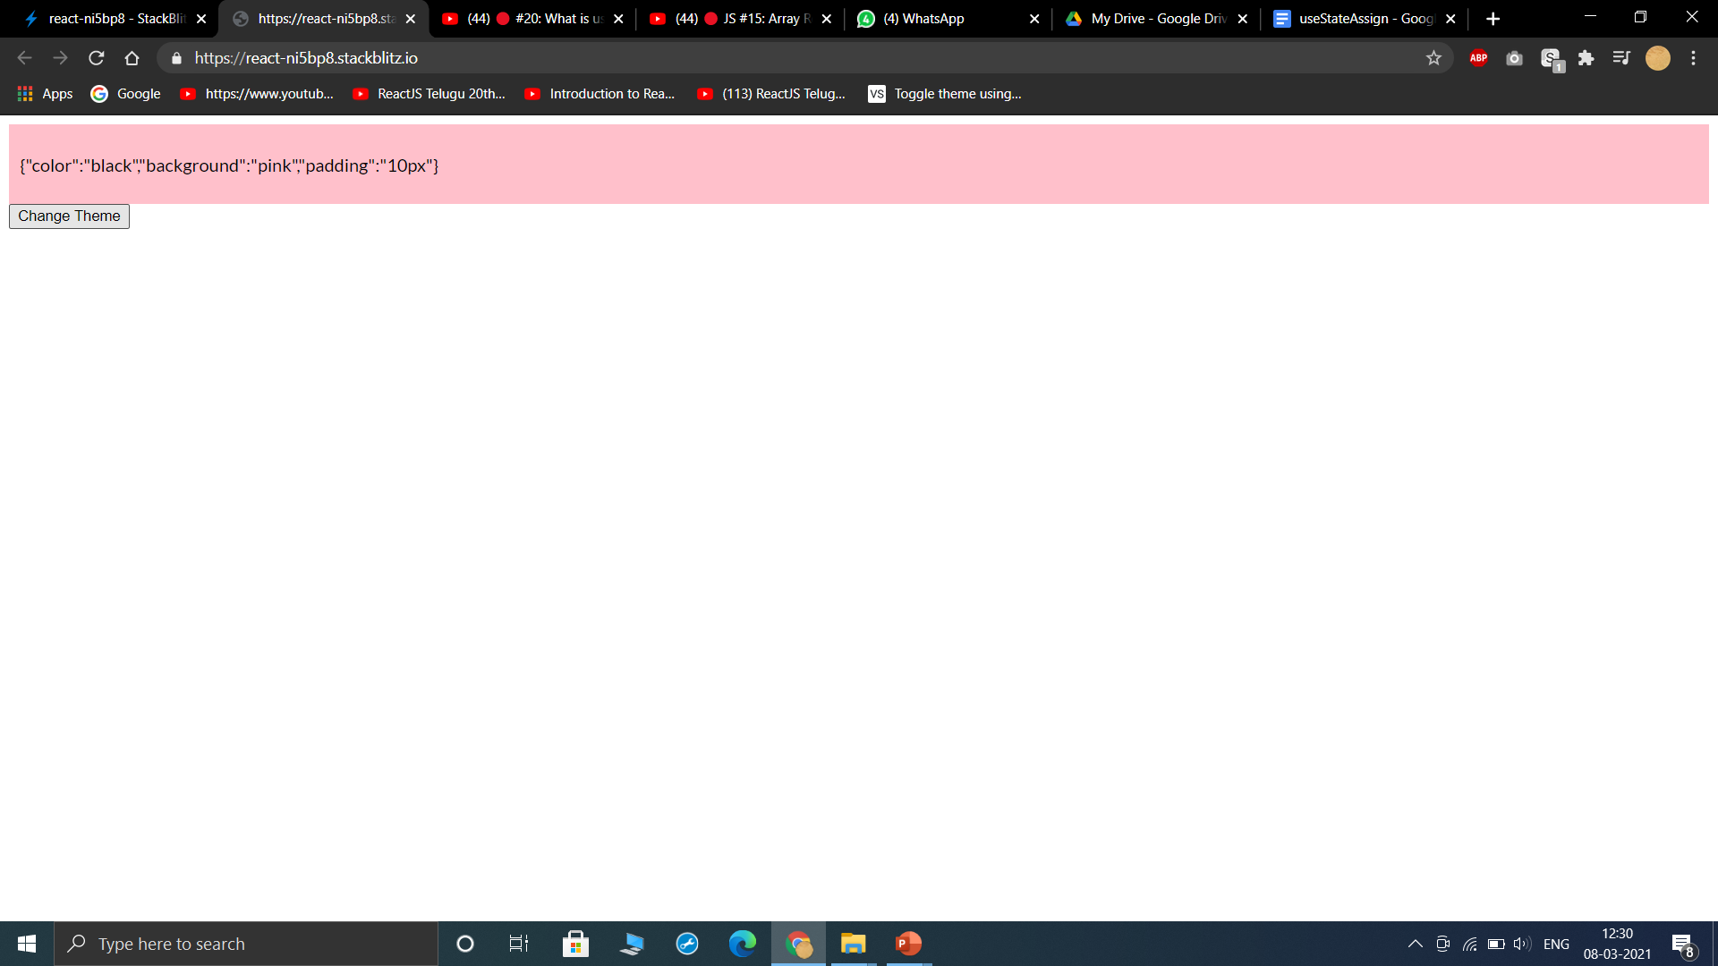

**6.Create a rating assignment using useReducer Hook.**

